1. **Activity 1**

|  |  |  |  |  |  |
| --- | --- | --- | --- | --- | --- |
| Task Mode | Task Name | Duration | Start | Finish | Predecessors |
| Auto Scheduled | H/W Selection | 6 days | Fri 7/1/22 | Fri 7/8/22 | - |
| Auto Scheduled | System Configuration | 4 days | Fri 7/1/22 | Wed 7/6/22 | - |
| Auto Scheduled | Install H/W | 3 days | Fri 7/1/22 | Tue 7/5/22 | - |
| Auto Scheduled | Data Migration | 4 days | Mon 7/11/22 | Thu 7/14/22 | 1 |
| Auto Scheduled | Draft Office Procedure | 3 days | Thu 7/7/22 | Mon 7/11/22 | 2 |
| Auto Scheduled | Recruit Staff | 10 days | Fri 7/1/22 | Thu 7/14/22 | - |
| Auto Scheduled | User Training | 3 days | Fri 7/15/22 | Tue 7/19/22 | 5,6 |
| Auto Scheduled | install and Test System | 2 days | Fri 7/15/22 | Mon 7/18/22 | 3,4 |

**Gantt chart**

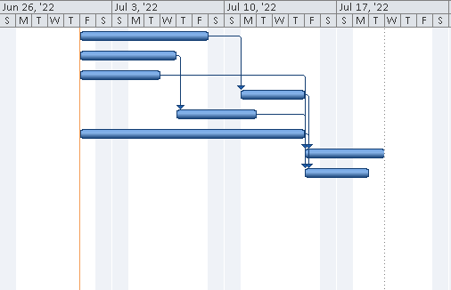

**Network Diagram**

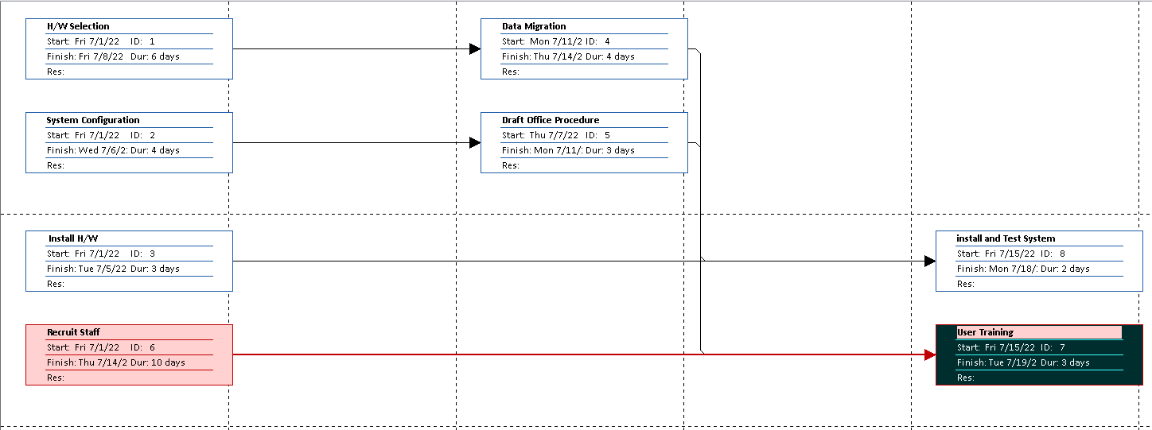

1. **Activity 2**

|  |  |  |  |  |  |
| --- | --- | --- | --- | --- | --- |
| Task Mode | Task Name | Duration | Start | Finish | Predecessors |
| Auto Scheduled | A | 1 day | Fri 7/1/22 | Fri 7/1/22 |  |
| Auto Scheduled | B | 1 day | Fri 7/1/22 | Fri 7/1/22 |  |
| Auto Scheduled | C | 5 days | Mon 7/4/22 | Fri 7/8/22 | 1 |
| Auto Scheduled | D | 1 day | Mon 7/4/22 | Mon 7/4/22 | 2 |
| Auto Scheduled | E | 1 day | Mon 7/4/22 | Mon 7/4/22 | 2 |
| Auto Scheduled | F | 6 days | Tue 7/5/22 | Tue 7/12/22 | 4 |
| Auto Scheduled | G | 4 days | Tue 7/5/22 | Fri 7/8/22 | 5 |
| Auto Scheduled | H | 2 days | Wed 7/13/22 | Thu 7/14/22 | 6 |
| Auto Scheduled | I | 1 day | Mon 7/11/22 | Mon 7/11/22 | 7 |
| Auto Scheduled | J | 1 day | Mon 7/11/22 | Mon 7/11/22 | 7 |
| Auto Scheduled | K | 3 days | Fri 7/15/22 | Tue 7/19/22 | 8 |
| Auto Scheduled | L | 3 days | Tue 7/12/22 | Thu 7/14/22 | 9 |
| Auto Scheduled | M | 1 day | Mon 7/11/22 | Mon 7/11/22 | 3 |
| Auto Scheduled | N | 1 day | Tue 7/12/22 | Tue 7/12/22 | 10 |

**Gantt chart**

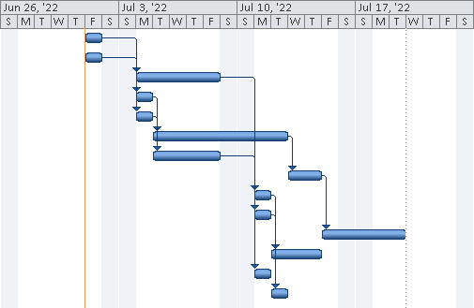

**Network Diagram**

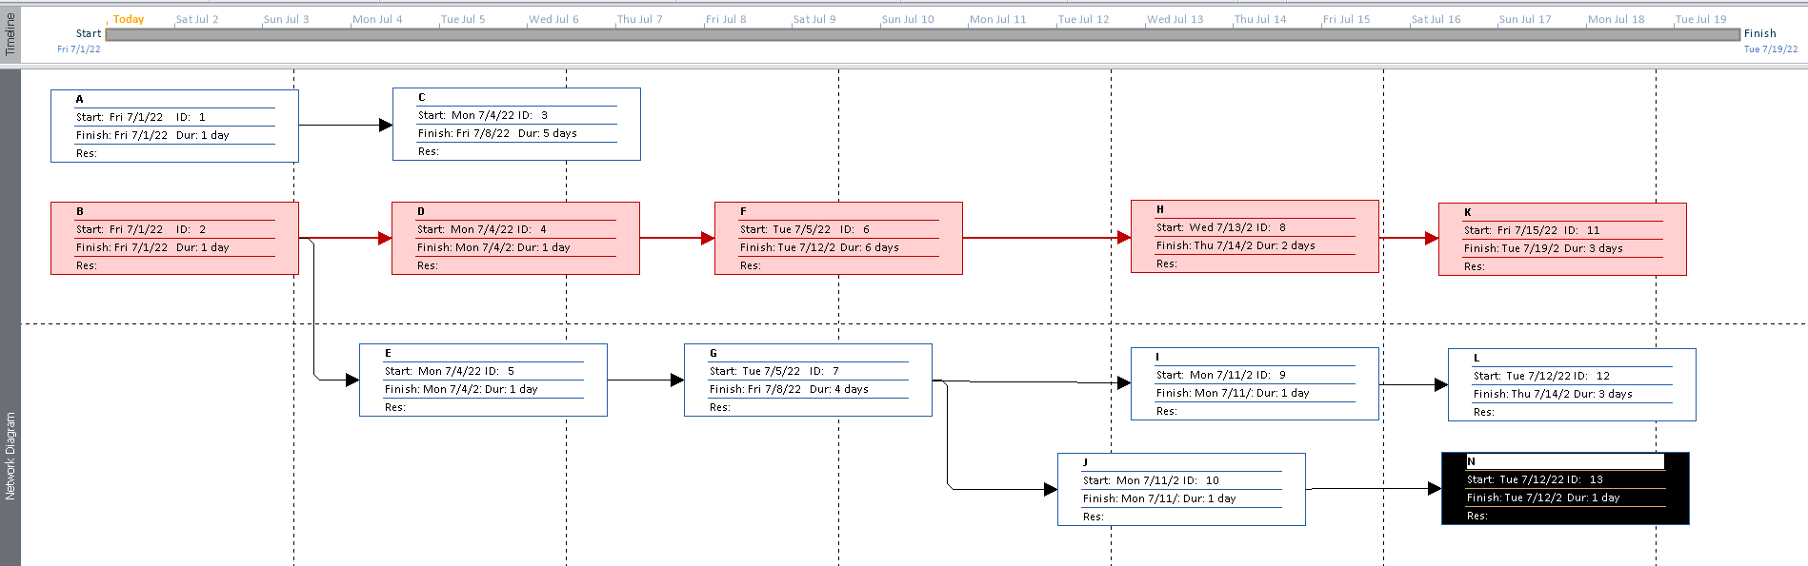

1. **Activity 3**

|  |  |  |  |  |  |
| --- | --- | --- | --- | --- | --- |
| Task Mode | Task Name | Duration | Start | Finish | Predecessors |
| Auto Scheduled | Event Planning | 4 days | Fri 7/1/22 | Wed 7/6/22 |  |
| Auto Scheduled | Marketing | 3 days | Thu 7/7/22 | Mon 7/11/22 | 1 |
| Auto Scheduled | Sponsors | 2 days | Tue 7/12/22 | Wed 7/13/22 | 2 |
| Auto Scheduled | Public Relation | 1 day | Thu 7/14/22 | Thu 7/14/22 | 3 |
| Auto Scheduled | Tendering Process | 2 days | Tue 7/12/22 | Wed 7/13/22 | 2 |
| Auto Scheduled | Event Production | 8 days | Thu 7/14/22 | Mon 7/25/22 | 5 |
| Auto Scheduled | Décor Design | 10 days | Fri 7/15/22 | Thu 7/28/22 | 4 |
| Auto Scheduled | Audio Visual Preparation | 2 days | Tue 7/12/22 | Wed 7/13/22 | 2 |
| Auto Scheduled | Cat and Demo | 3 days | Tue 7/12/22 | Thu 7/14/22 | 2 |
| Auto Scheduled | Final Fashions Items | 3 days | Fri 7/29/22 | Tue 8/2/22 | 7,6,9 |
| Auto Scheduled | Press and Guest Invitations | 2 days | Thu 7/14/22 | Fri 7/15/22 | 8 |
| Auto Scheduled | Setting up of Structure | 3 days | Wed 8/3/22 | Fri 8/5/22 | 10,11 |
| Auto Scheduled | Final Drill | 1 day | Mon 8/8/22 | Mon 8/8/22 | 12 |

**Gantt chart**

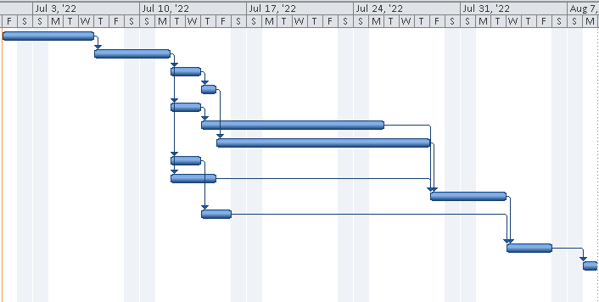

**Network Diagram**

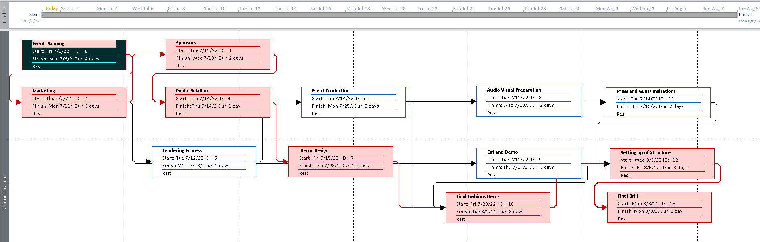

1. **Activity 4**

Create your teams project using Jira’s strong template prioritize all work on the backlog and goals, assigned rows, and manage time for sampling the project.

* Creating an Issue for prioritizing it

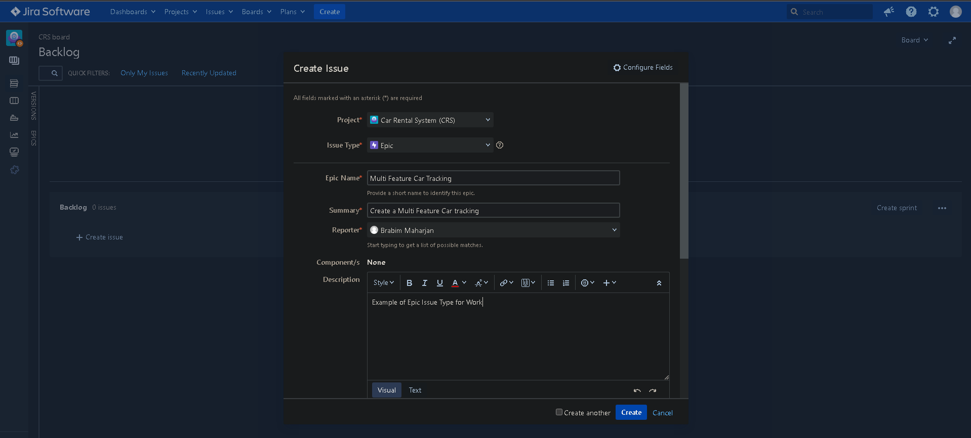

* Creating a Backlog

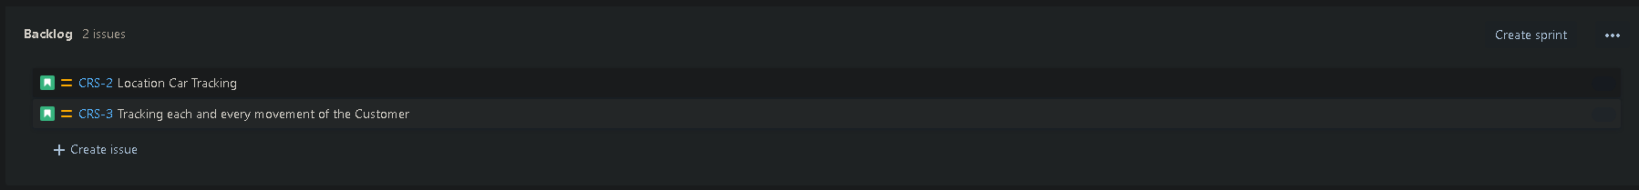

* Create a Sprint Cycle

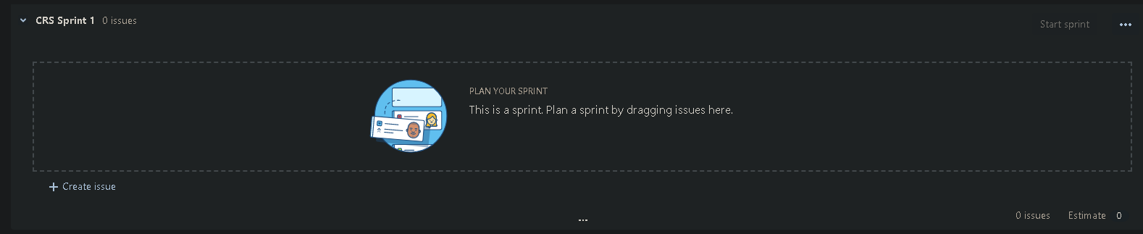

* Assigning Goals and Managing them

